|  |  |
| --- | --- |
| Assignment-1  **Mohammed Badruddin Saad - 301313784** | **Abstract**  Computer Peripherals, Hardware, applications, OS and Networking  **COMP120016_2022F:**  Software Engineering Technology |

# 

References:

1. Computer Fundamentals - Overview <https://www.tutorialspoint.com/computer_fundamentals/computer_overview.htm>  Tutorials Point 2020.
2. Computer System Architecture <https://www.tutorialspoint.com/Computer-System-Architecture>
3. *Memory Units :* <https://www.educba.com/memory-units/>
4. *Primary, Secondary and Cache Memory Pictures :* <https://excellencecoachingcentre.blogspot.com/2015/10/secondary-memory-and-three-its-three.html>
5. *Computer Architecture* : <https://en.wikipedia.org/wiki/Computer_architecture>
6. *Motherboard ports* : <https://learnlearn.uk/alevelcs/motherboard-ports/>
7. *Configuration of the computer :* <https://www.centennialcollege.ca/programs-courses/full-time/artificial-intelligence/>

<https://short-fact.com/what-is-the-best-configuration-when-purchasing-a-new-computer/>

1. Computer Fundamentals - Software <https://www.tutorialspoint.com/computer_fundamentals/computer_software.htm>
2. *Networking and Types :*

[https://www.geeksforgeeks.org/types-of-area-networks-lan-man-and-wan/#:~:text=LAN%2C%20MAN%2C%20and%20WAN%20are%20the%20three%20major,LAN%20and%20WAN%20comprises%20the%20largest%20of%20all.](https://www.geeksforgeeks.org/types-of-area-networks-lan-man-and-wan/%23:~:text=LAN%2C%20MAN%2C%20and%20WAN%20are%20the%20three%20major,LAN%20and%20WAN%20comprises%20the%20largest%20of%20all.)

1. *EPN:* <https://www.itrelease.com/2021/06/what-is-enterprise-private-network-epn-with-example/>
2. *Network diagrams:* [https://www.edrawsoft.com/lan-diagrams.html#:~:text=A%20LAN%20diagram%20is%20a%20visual%20representation%20of,a%20LAN%20diagram%20is%20referred%20to%20as%20topologies.](https://www.edrawsoft.com/lan-diagrams.html%23:~:text=A%20LAN%20diagram%20is%20a%20visual%20representation%20of,a%20LAN%20diagram%20is%20referred%20to%20as%20topologies.)

**Objective: Learn about computer peripherals and hardware**

**Question 1: Describe computer components, and include pictures**

1. Computer architecture
2. CPU
3. IO devices
4. Memory
5. Memory units
6. Motherboard ports
7. Other latest devices
8. Computer Architecture: - The architecture of the computer system is everything from the user at the top, to the software, the operating system, the firmware, and the hardware all the way at the bottom. It is everything in between. The interrelationship between the separately specified components of a computer system and its structure defines the architecture of that computer system.

All computers follow the same basic logical structure and performs the five basic operations like inputting the data, storing data, processing data, displaying output and controlling the workflow.

1. Central Processing Unit (CPU):- It is the brain of the computer, which performs all type of data processing operations, storing data, intermediating results and instructions. There are three components to CPU.

* Arithmetic Logical Unit, Memory Unit and Control Unit.

1. Input/output Devices: -

**Input devices** are the devices, with the help of which we enter data into the computer. They translate information into a form that is understandable by the computer.

Example: Keyboard, Microphone, Mouse, Touchpad, Scanner, Camera, and Joystick etc.

**Output devices** are responsible for conveying the information from the computer to us. They translate the information into a form that is understandable by the users.

Example: Projector, Monitor, Speakers, Headphones, printer, plotter etc.

1. Memory: Computer memory is a storage space in the computer, where data is to be processed and instructions required for processing are stored. Memory is divided into large number of small parts called cells, where each cell has a unique address.

There are three types of memory:

* Primary memory/Main memory
* Secondary memory
* Cache memory

1. Memory Units: The amount of data that can be stored in a single memory location, called storage unit defines a memory unit. These memory units are used to indicate the number or amount of data that are picked and used for individual computation processes performed in a computing device.

* The storage capacity is expressed in terms of a smallest unit called bytes, which is a collection of 8 bits. A byte can represent a data item or a character.
* A bit represents passive or an active state of a component in an electric circuit. The data is shown either in 0 or in 1.
* Nibble is a collection of 4 bits, which is characterized as hexadecimal number to store the data in memory.

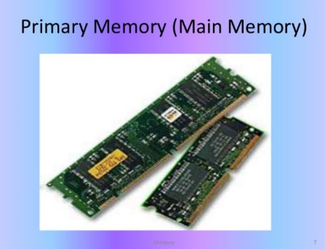 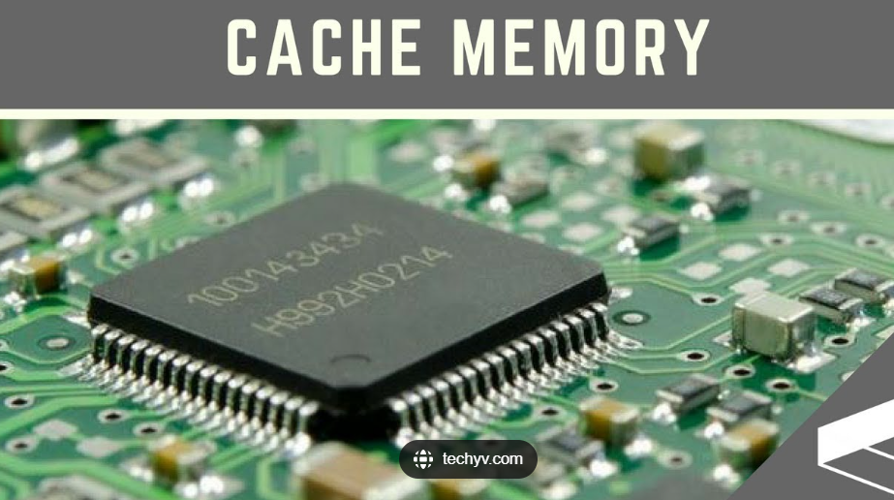

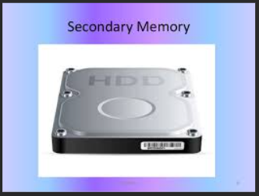

1. Motherboard Ports: Motherboard is a single platform or connection point, which connects all parts of the computer together. All motherboards have different ports depending on their date of manufacture and their purpose.

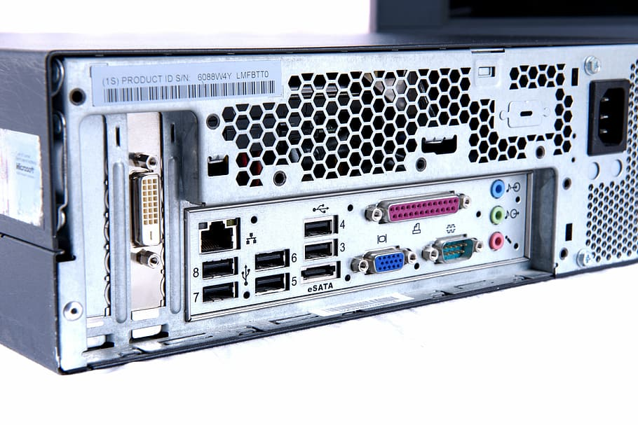

Motherboard ports picture by learnlearn.uk

Motherboard ports can connect Monitor, printer, mouse, keyboard, speaker, network cables, USB portable devices etc.

1. Other latest devices: Some of the latest devices are

* Mac Mini: World’s smallest desktop computer.
* Tablet PC’s: Mobile versions of desktop computer.
* Ultra Book: It gives laptop and tablet 2 in 1 service.

**Question 2:**

**What is the best configuration when purchasing a new computer?**

A desktop computer can be assembled or it can be bought from a brand, were all the components will be of the same brand. Depending on how we intend to use our computer, will mainly affect our decision when purchasing a new computer.

* Assembled :- All the components will have different brands
* Branded :- All the components will be of the same brand

Following are some of the factors that needs to be considered, before purchasing a computer:

1. A desktop, can be purchased based on the processing power, and the processor (brain of the computer) can be any of brand Intel-M, i3, i5, i7, AMD-A4, A6, A8, FX, apple-M1, and M2 etc. Each processor can have different number of cores (number of CPU’s) which is related to the number of programs that can be executed simultaneously.
2. Price will also be different based on processors response rate, as every processor will have different cache memory.
3. Processors frequency i.e., ability to perform different number of instructions cycles executed per sec (GHz), will also impacts price.
4. Primary and Secondary memory sizes and types (SSD or HDD).
5. Graphic Cards quality, which is essential for gamers.
6. Resolution of the Monitor.
7. Operating system says is the heart of the computer, and if the specification says DOS, then a separate operating system is required to be installed. However, common OS’s are windows-10, Linux, OS X etc.,
8. Battery life.
9. Finally, Number of Motherboard ports, and its speed will also have an effect on the price.

For a software engineer who is responsible to run machine learning models and use programming tools like Python, R, Hadoop, SQL, Visual studio, and studio code etc., Following is the best configuration:

Windows operating system –Windows 10, X64 processor

Intel Core i7 Processor (latest generation)

Or AMD equivalent processor or MacOS

Geforce GTX 1060 6GB graphic card

500 GB SSD Drive

16 GB Memory

USB + HDMI ports

15” FHD resolution screen

Built in Webcam; Audio/Mic Combo

Wireless Card that supports 802.11 n/ac protocols and WPA2 Enterprise

Battery life of 3hrs or more.

**Objective: Learn about computer applications, OS and networking.**

Research the following topics. Include suitable diagrams.

1. Application software with examples
2. Systems software with examples
3. Explain operating systems with examples
4. Networking and its types (LAN, WAN, WLAN, MAN, SAN, PAN, EPN & VPN)
5. Application Software/ End-user Software / Productivity Software:

Software is a generic term used to describe computer programs. A computer program, which can execute a certain personal, educational and business functions automatically, is known as an application software. Every application is designed to facilitate end-users in completing wide range of tasks related to productivity, efficiency, creativity or communication.

This software can perform single or multiple tasks at the same period, and it helps in providing a GUI to the user to operate the computer for different functionality. The application software are mainly of the following types:

1. General Purpose Software
2. Custom made Software

* General Purpose Software: - This software is available for everyday user and is used for day-to-day activities by the user.

Example: - MS word, Excel, Microsoft teams, Gmail, and Gdrive etc.

* Custom Made Software: - The requirement of a user can be fulfilled by developing a custom software known as custom-made software.

Example: - Web application, Mobile application, data base software and desktop software application.



1. General Purpose Software b) Custom Made Software
2. System Software: It is the collection of programs designed to operate, control and extend the processing capabilities of the computer itself. This software provides platforms to other software’s and contain programs written in low level languages, which can be used to interact with the hardware at a very basic level. It serves as the interface between the hardware and the end users.

Examples: Operating system, file management utilities, and disk operating systems (DOS), compilers, assemblers etc.



1. Windows b) Linux c) Apple-OS
2. Operating System: A program that acts as an interface between the software and the computer hardware. It provides common services for computer programs. It controls and keep a record of the execution of all other programs that are present in the computer, including application programs and other system software.

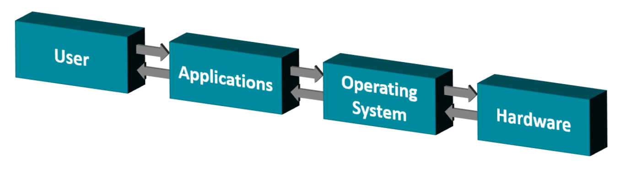

Some of the important tasks performed by the OS:

* Memory management: Keeps track of primary memory and allocates the memory when the process requests it.
* Processor management: Allocates the main memory (RAM) to a process and de-allocates it when it is no longer required.
* File-management: Allocates and de-allocates the resources and decided who gets the resources.
* Security: prevents unauthorized access to programs and data by means of passwords.
* Error detecting Aids: production of error messages and other debugging and error-detecting messages.
* Scheduling: The OS schedules process through its scheduling algorithms.
* Job Accounting: Keeps track of time and resources used by various jobs and other users.
* Control over performance: Records delays between the request for a service and from the system.
* Interaction with the operators
* Coordination between other software’s and users

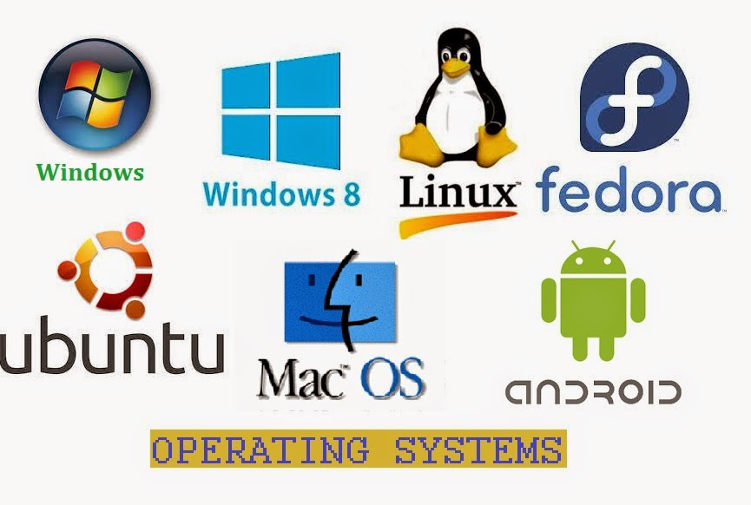

1. Networking: A computer network can be described as a system of interconnected devices that can communicate using some common standards (called **protocols**). These devices communicate to exchange resources (e.g. files and printers) and services. To connect more than two devices a network device called switch or a hub is use.

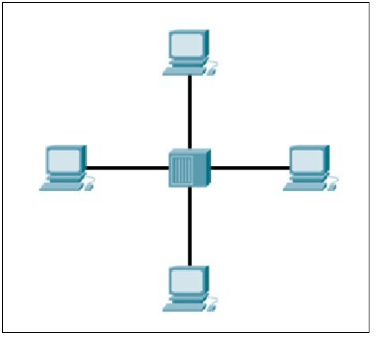

Types of Networking:-

* Local Area Network (LAN): Connects network devices in such a way that personal computers and workstations can share data, tools and programs.

The group of computers and devices are connected together by a switch or a stack of switches, using private addressing scheme as defined by the TCP/IP protocol. Client server LAN and peer to peer LAN are two basic types of LAN’s

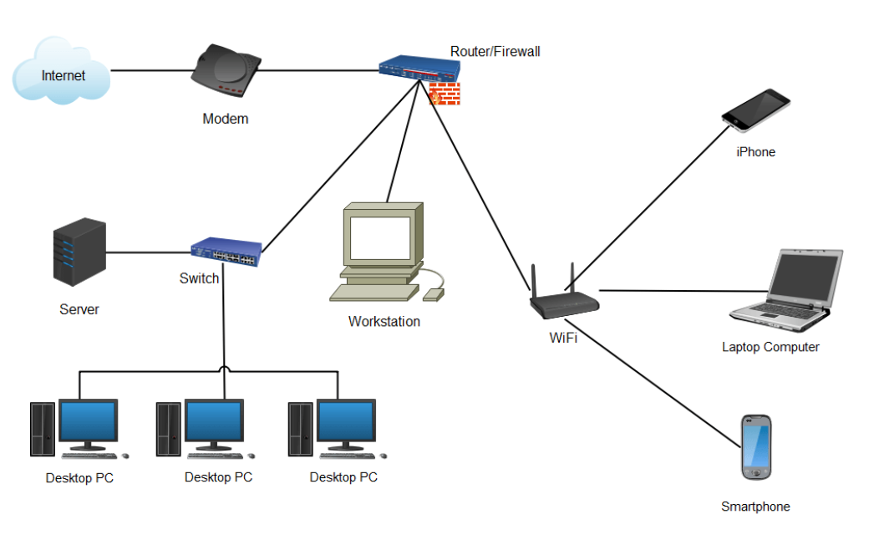

LOCAL AREA NETWORK DIAGRAM

* Wide Area Network (WAN): Wide Area Network is a computer network that extends over a large geographical area, although it might be restricted within the boundaries of a state or country. A WAN could be a connection of LAN connecting to other LANs via telephone lines and radio waves and may be confined to an enterprise (a corporation or an organization) or accessible to the public. The technology is high speed and relatively expensive.

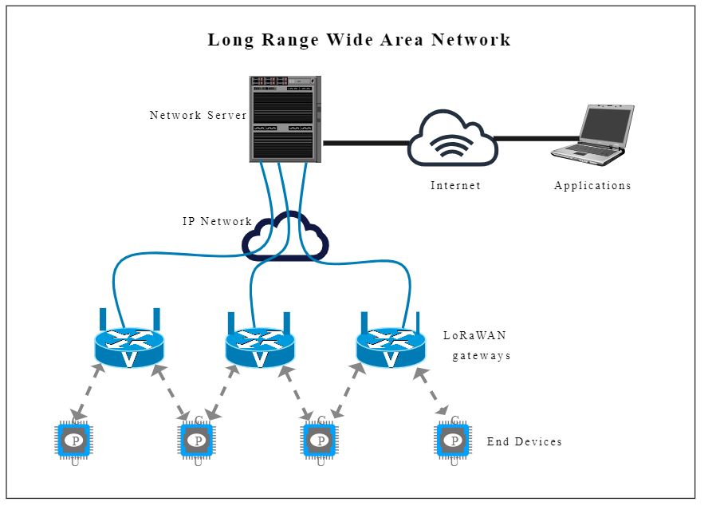

* Wireless Local Area Network (WLAN): Connects network devices in such a way that personal computers and workstations can share data, tools and programs wirelessly.

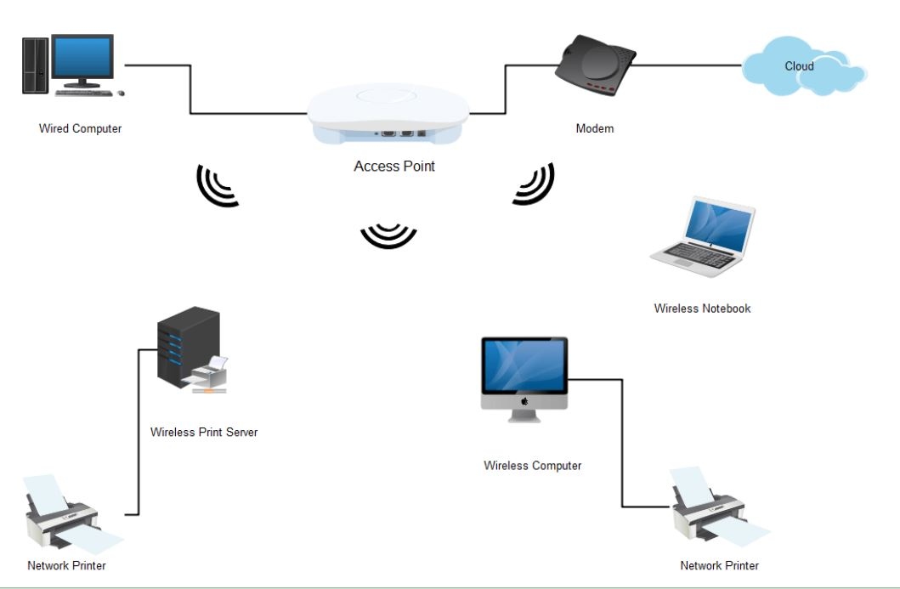

Wireless Local Area Network

* Metropolitan Area Network (MAN): Metropolitan area Network covers a larger area than that of a LAN and smaller area as compared to WAN. It connects two or more computers that are apart but reside in the same or different cities. It entails a large geographical area and may serve as an ISP (Internet Service Provider). MAN is designed for clients with high-speed connectivity requirement.

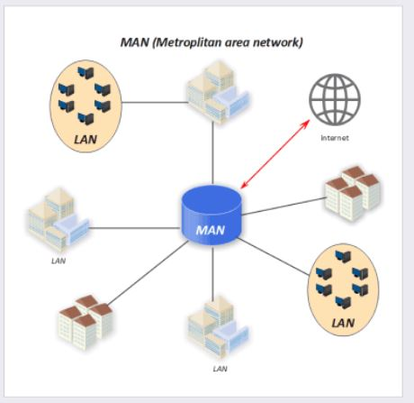

* Storage Area Network (SAN): SAN is dedicated network tailored to a specific environment - combining servers, storage systems, networking switches, software and services.

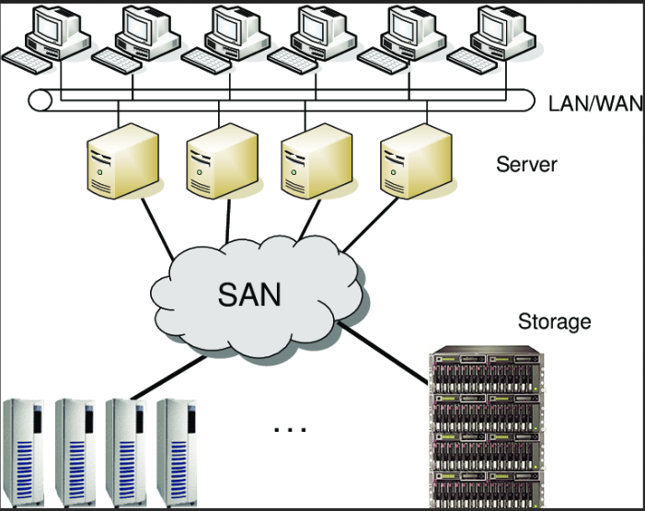

Storage Area Network

* Personal Area Network (PAN): PAN is a computer network,that connects computers/devices within the range of an individual person. The range of PAN is within 10 meters, and it typically involves a computer, phone, tablet, printer, and other entertainment devices.

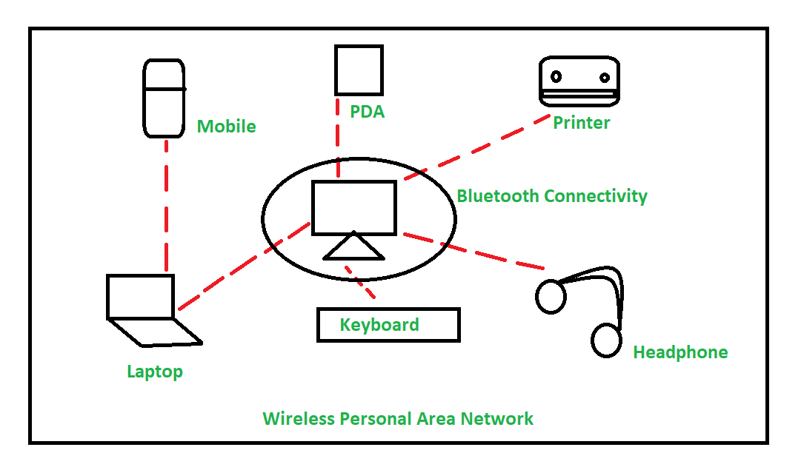 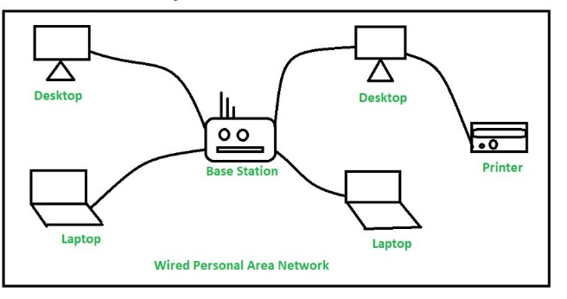

Wireless PAN Wired PAN

* Enterprise Private Network (EPN): An enterprise private network is a computer network built by a business to interconnect its various company sites (such as production sites, offices and shops) in order to share computer resources.
* Virtual Private Network (VPN): It is a technology that creates a safe and encrypted connection over a less secure network, such as the internet. A Virtual Private Network is a way to extend a private network using a public network such as the internet. The name only suggests that it is a Virtual “private network” i.e. user can be part of a local network sitting at a remote location. It makes use of tunneling protocols to establish a secure connection.

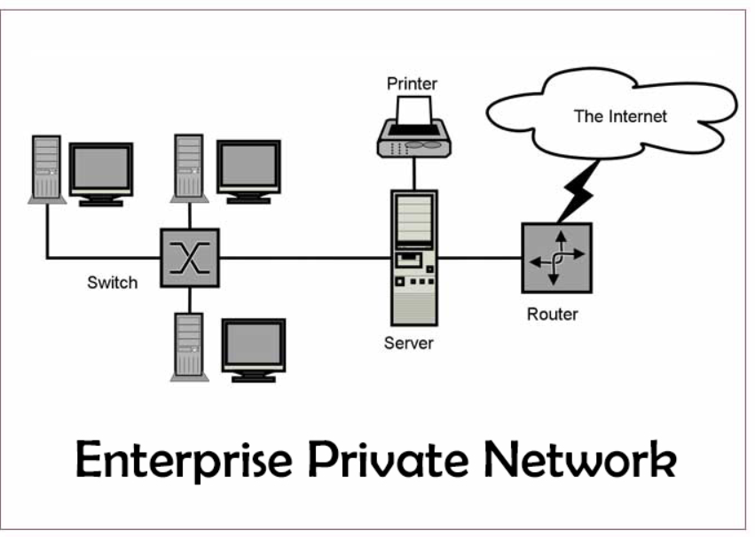

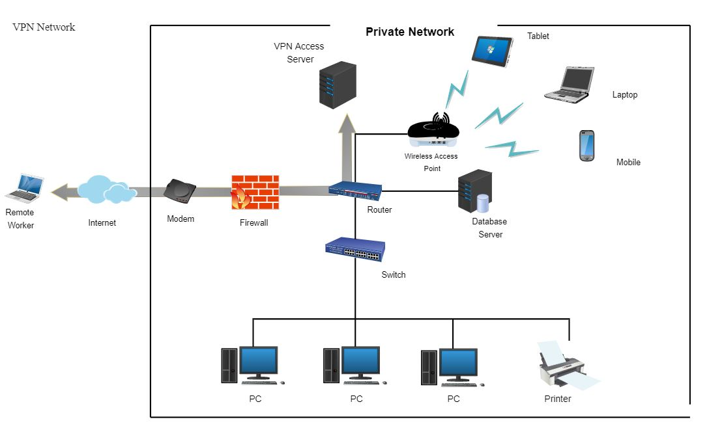

Virtual Private Network